ASTA 607-COMPUTATIONAL STATISTICS 1
SAMUEL NII OKPOTI ADJEI
PRACTICAL EXAMINATION

QUESTION 1
a) Data description
?crabs
#The crabs data frame has 200 rows and 8 columns, describing 5
#morphological measurements on 50 crabs each of two color forms and both sexes,
#of the species Leptograpsus variegatus collected at Fremantle, W. Australia.

b) Loading data set AND DISPLAY THE STRUCTURE

Data input:
Loading data set AND DISPLAY THE STRUCTURE
install.packages("MASS")
library(MASS)
data("crabs")
View(crabs)
str(crabs)
Data output:
'data.frame': 200 obs. of 8 variables:
$ sp : Factor w/ 2 levels "B","O": 1 1 1 1 1 1 1 1 1 1 ...
$ sex : Factor w/ 2 levels "F","M": 2 2 2 2 2 2 2 2 2 2 ...
$ index: int 1 2 3 4 5 6 7 8 9 10 ...
$ FL : num 8.1 8.8 9.2 9.6 9.8 10.8 11.1 11.6 11.8 11.8 ...
$ RW : num 6.7 7.7 7.8 7.9 8 9 9.9 9.1 9.6 10.5 ...
$ CL : num 16.1 18.1 19 20.1 20.3 23 23.8 24.5 24.2 25.2 ...
$ CW : num 19 20.8 22.4 23.1 23 26.5 27.1 28.4 27.8 29.3 ...
$ BD : num 7 7.4 7.7 8.2 8.2 9.8 9.8 10.4 9.7 10.3 ...

c) frequency table for species and sex
freq_tab_spe_sex<- table(crabs$sp, crabs$sex)
Data output:
F M
B 50 50
O 50 50

d)
barplot(freq_tab_spe_sex,beside = TRUE,main = "Crab Counts by Species and Sex",xlab = "Species", ylab = "Number of Crabs",ylim = c(0, 60))
OUTPUT

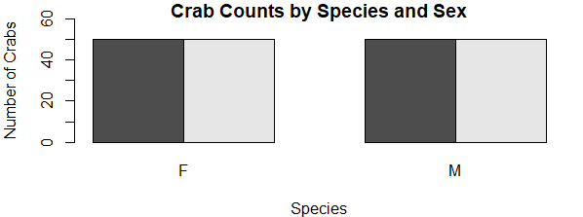

e) Comment
# There are 50 observations in each combination of species (B, O) and sex (M, F),
#giving 4 groups with equal sample sizes.

#This means comparisons between groups are not affected by unequal sample sizes.
QUESTION 2
a)
par(mfrow=c(1,2),mar=c(4,4,1,1))
boxplot(BD~sp,data = crabs,main= "Boxplot of BD by species",
xlab="Crab species",ylab="Body Dept",col = c("lightblue", "lightgreen"))

boxplot(BD~sex,data =crabs,main= "Box of BD by sex",
xlab = "Crab sex",ylab = "Body Debt",col=c("pink","orange") )

OUTPUT
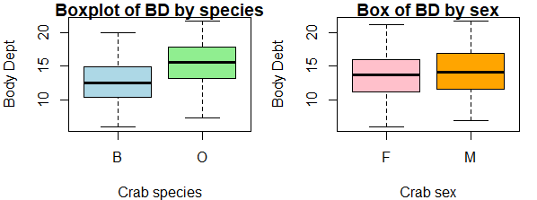

b) There are no outliers here in this groups.
Central Tendency (Median)
By Species:
Species O has a higher median body depth than Species B.

This suggests Orange crabs tend to have deeper bodies on average.
By Sex:
Males and females have similar medians, though males appear slightly higher.
The difference by sex is smaller than the difference by species.

Question 3
a)
CODE INPUT:
# Histogram for species B
hist(crabs$CL[crabs$sp == "B"],
main = "Histogram of Carapace Length (Species B)",
xlab = "Carapace Length (CL)",
col = "skyblue",
border = "black")

# Histogram for species O
hist(crabs$CL[crabs$sp == "O"],
main = "Histogram of Carapace Length (Species O)",
xlab = "Carapace Length (CL)",
col = "lightgreen",
border = "black")

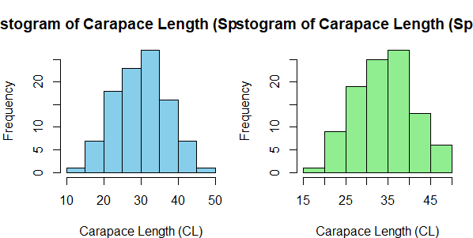

b) Both species show roughly bell-shaped distributions, indicating that carapace length is approximately normally distributed in each group. The distributions are unimodal, with a single clear peak around the central values, suggesting most crabs have lengths near the mean. Species O appears slightly right-skewed with more larger values, while Species B is more symmetric, indicating slightly less variability toward higher carapace lengths.

QUESTION 4

a)
Input for means:
morph_means<- colMeans(crabs[,4:8])
print(morph_means)
apply(crabs[,c("FL","RW","CL","CW","BD")],2,mean)
Output:
FL RW CL CW BD
15.5830 12.7385 32.1055 36.4145 14.0305

QUESTION 5
a)
pairs(crabs[,c("FL","RW","CL","CW","BD")],main="Scatter plot matrix
OF MOPHORLOGICAL MEASUREMENT")

OUTPUT:
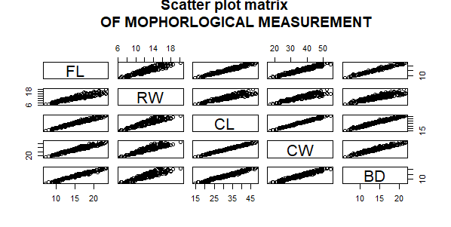

b) The diagram above indicated that there exist a positive relationship between the variables

